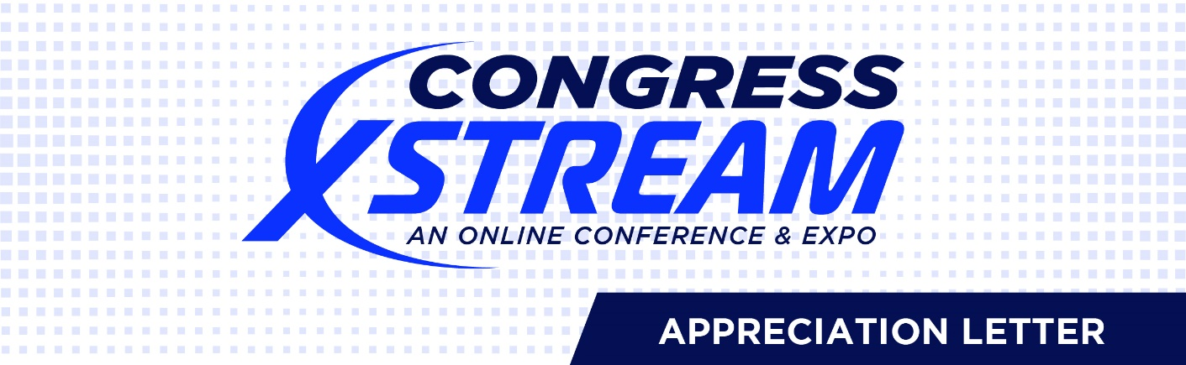

Memorandum
To: [name of your manager and/or person who approved your request to attend Global Congress Xstream]
cc: Finance
From: [your name here]
Date: [fill in as appropriate]
Re: Return on Training Investment

Thanks to your support, I recently attended Global Payroll Management Institute’s (GPMI) Global Congress Xstream: An Online Conference & Expo. At this virtual four-day conference, I learned a great deal that will directly benefit our organization’s bottom line.

Presented in cooperation with the American Payroll Association, this unique event provided timely compliance education that will assist us as we support and expand our global payroll operations. I attended insightful workshops covering many aspects of global payroll including deployment strategies, compliance, and regulations. I learned about new and emerging payroll technologies that can improve productivity and cost-effectiveness, as well as a number of trending challenges for payroll professionals and the solutions being implemented. I am examining these new practices to see what may apply to our operations.

[Insert an example of what you learned]

As a Global Congress Xstream attendee, I have online access to all handouts from the conference workshops and have pulled all the relevant material together as a department resource.

Thank you for allowing me to attend Global Congress Xstream and for supporting my continuing education. I assure you that what I have learned and the contacts I have made will help support our continued payroll compliance and the cost-effectiveness of our operations.

[Feel free to shorten or otherwise adapt this memo to fit your needs.]

